Kalyani Vishnu Bhat 23-Jul-17

Dear Kalyani

We refer to your resignation letter/email dated 09-May-17 which was accepted on

09-May-17. Please note that you have been relieved from ORXY SOLAR ENERGY (“Company”) effective close of business hours on 23-Jun-17

We are setting out below, details of your employment with the company:

Date of Joining : 03-Jun- 15

Last working day : 23- Jun- 17

Current Designation : Electronics Engineer

Gross salary as on last working day : Rs. 125772/- per annum

We thank you for your services and take this opportunity to wish you the very best in your future endeavors.

We would like to draw your attention to your continuing obligations towards the Company including that of confidentiality with respect to all proprietary and confidential information of the Company and its customers that you have had access to during your employment with the Company.

For ORXY SOLAR ENERGY

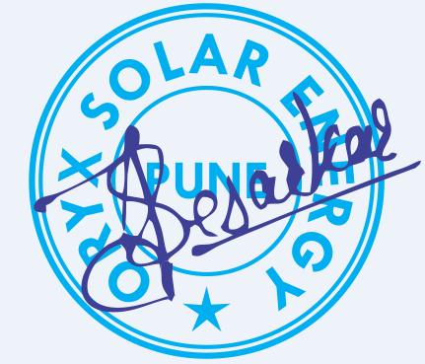

Authorized Signatory